EmployeeManagementRestAPI

* **Screenshot Showing Get API for Admin Role.**

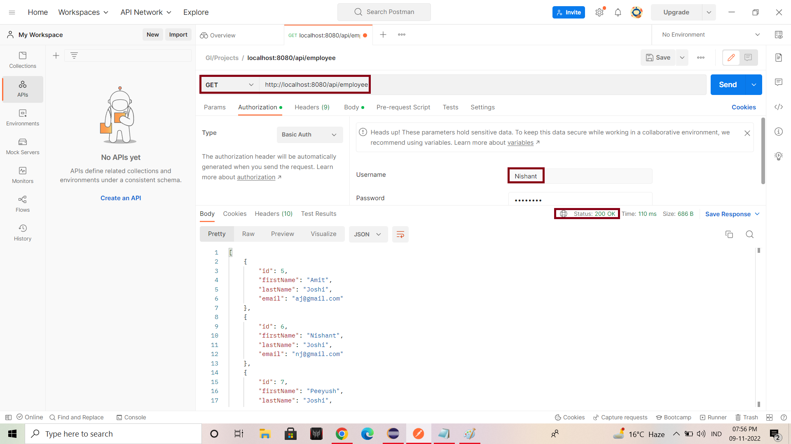

* **Screenshot Showing Get API for user Role.**

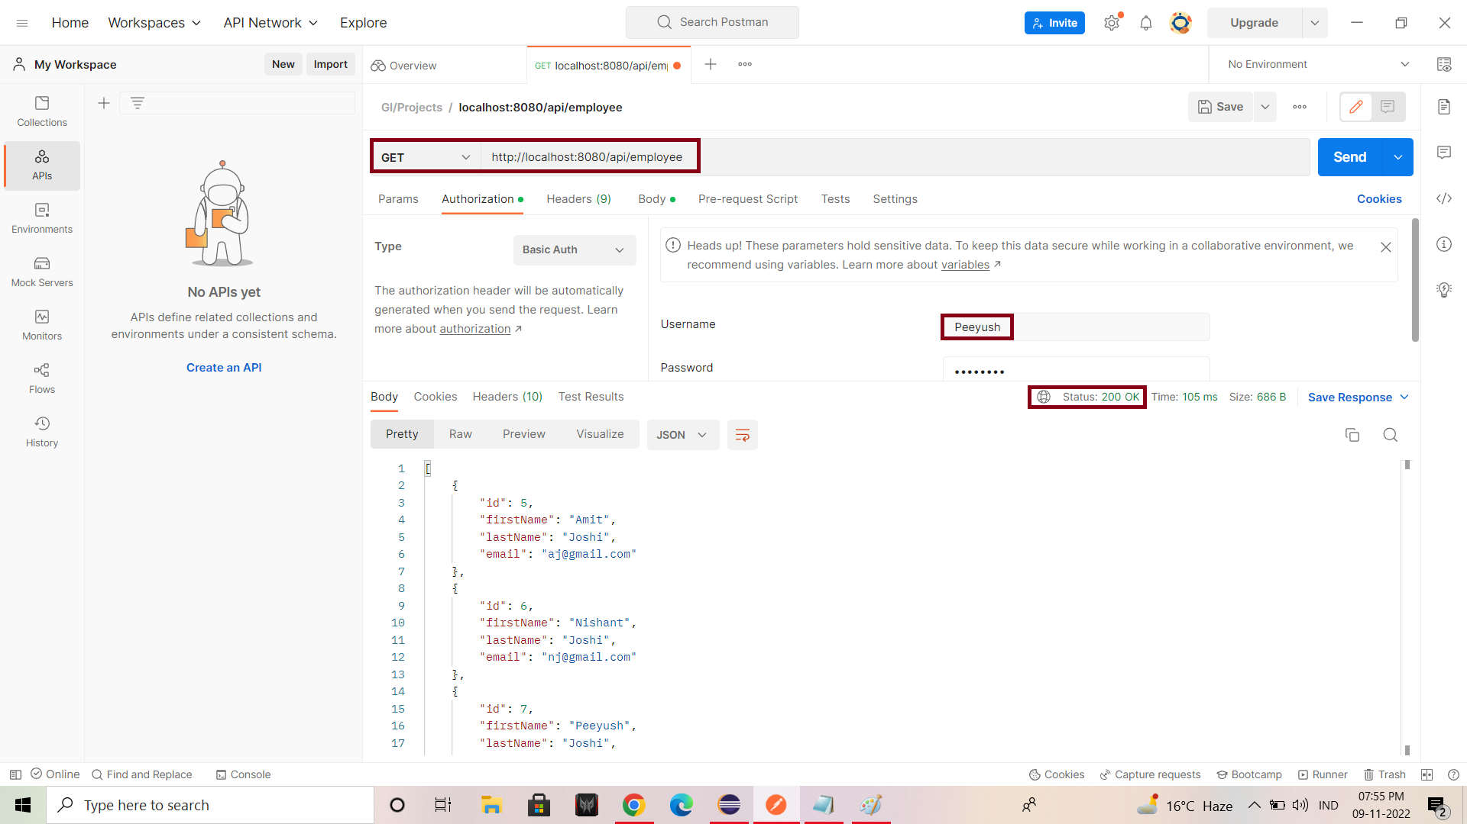

* **Screenshot showing Post API for Admin Role.**

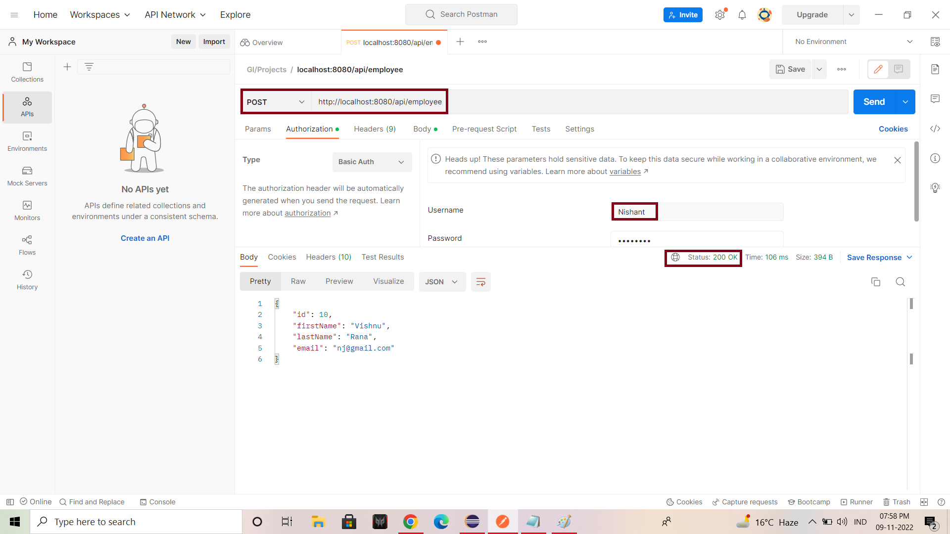

* **Screenshot showing Post API for user role.**

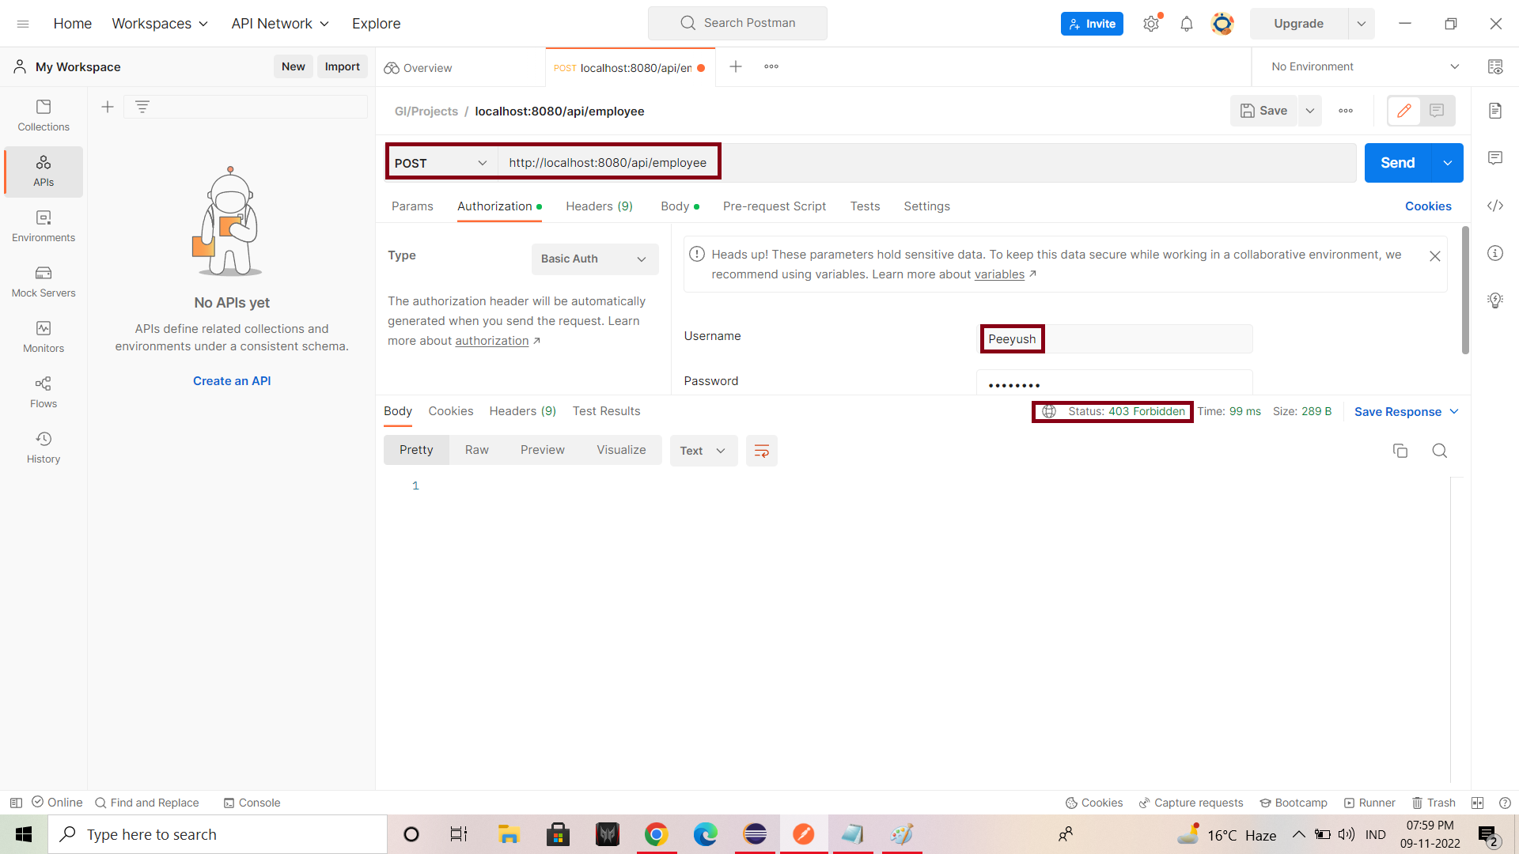

* **Screenshot Showing Put API for Admin Role.**

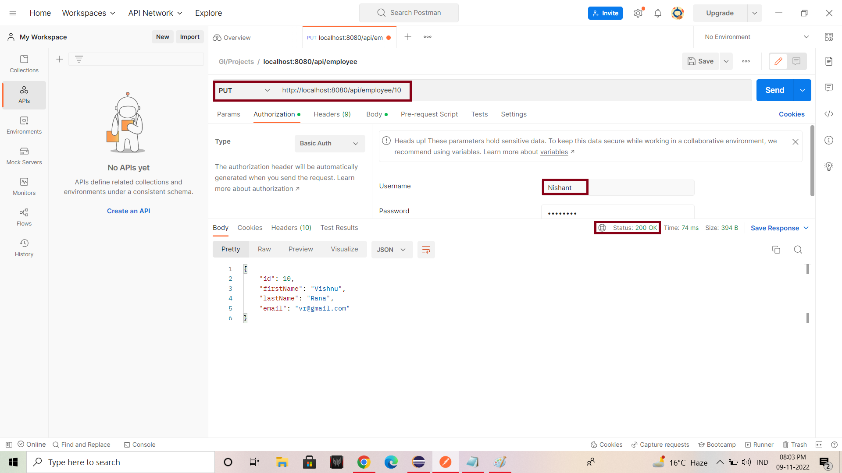

* **Screenshot showing Put API for User Role.**

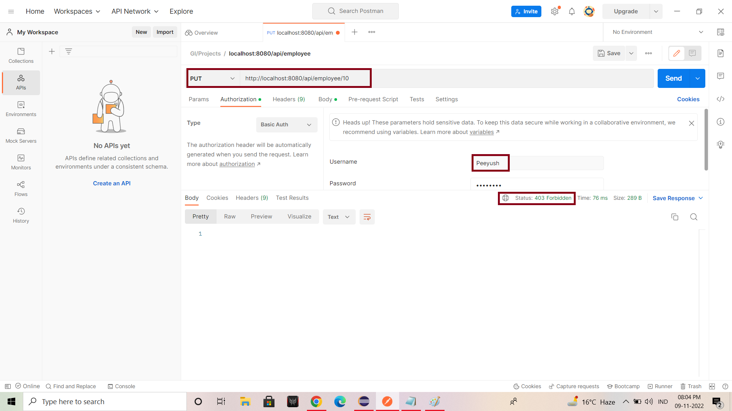

* **Screenshot showing GetbyID API for Admin Role.**

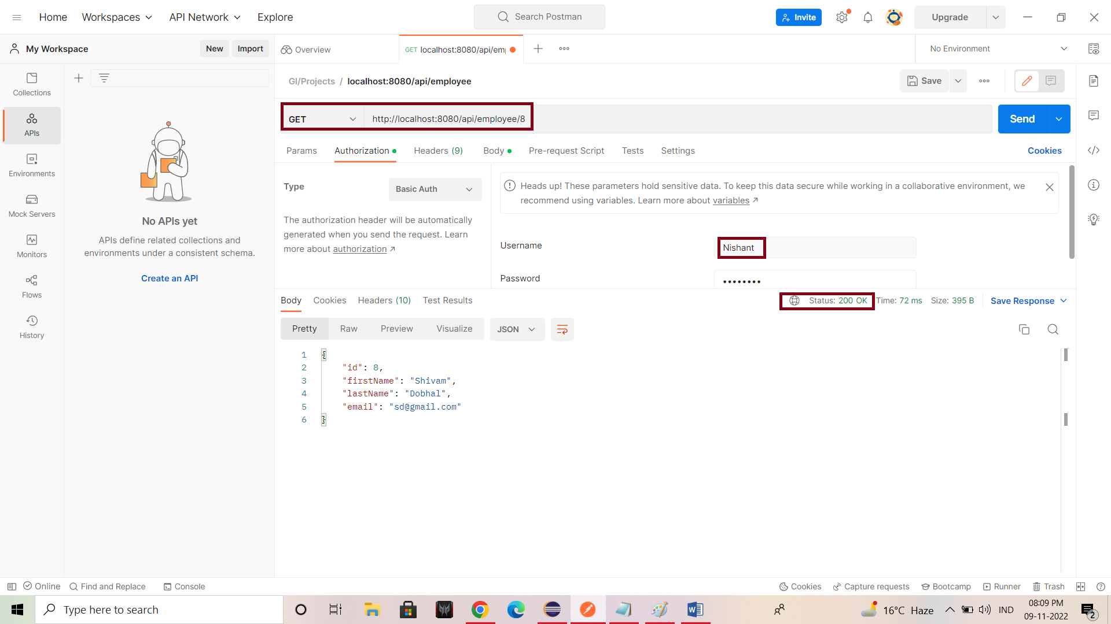

* **Screenshot showing GetbyID API for user Role.**

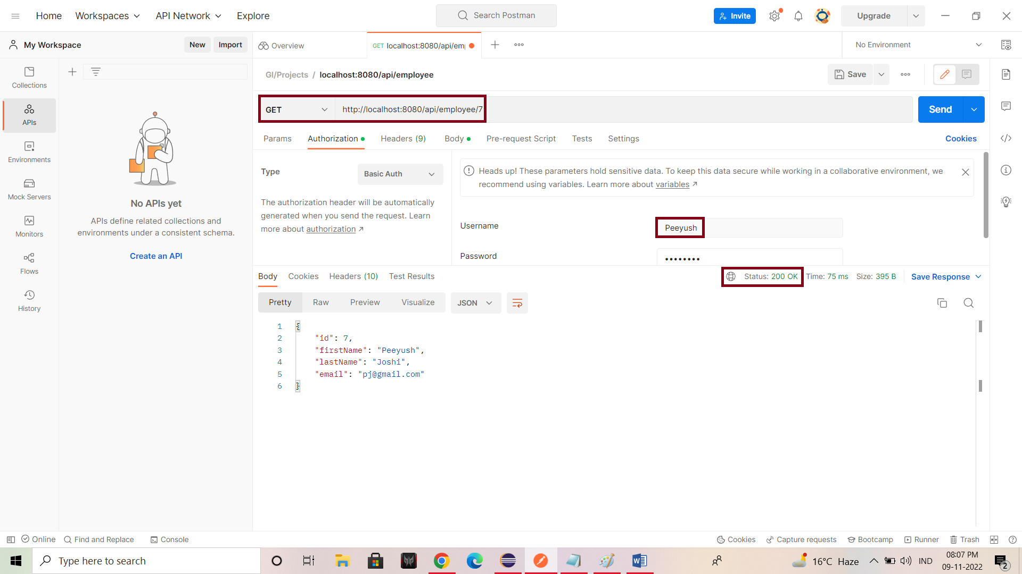

* **Screenshot showing GetSortedbyId API for Admin Role.**

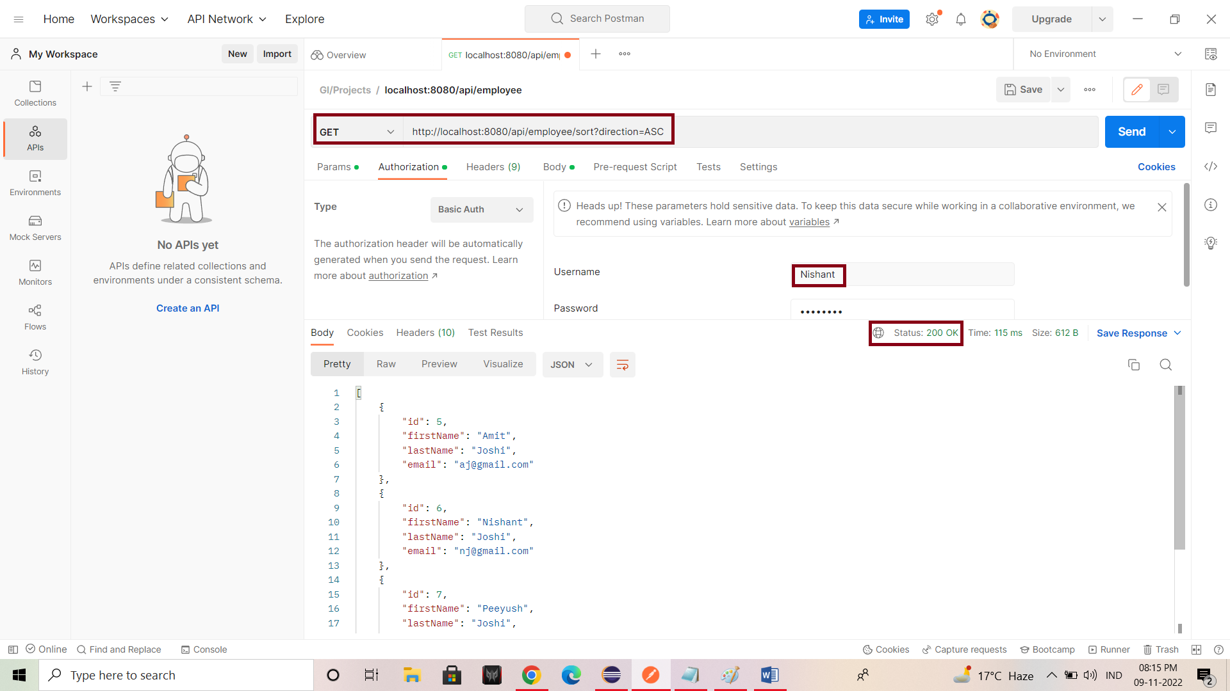

* **Screenshot showing GetSortedById API for User Role.**

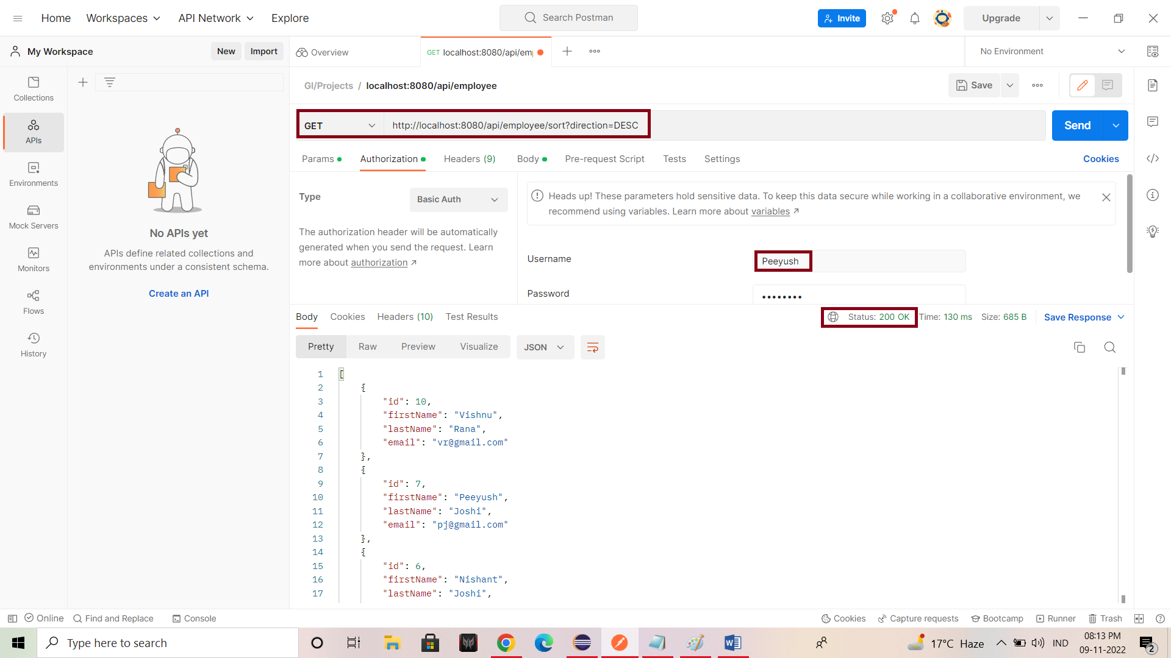

* **Screenshot showing DeleteById API for Admin Role.**

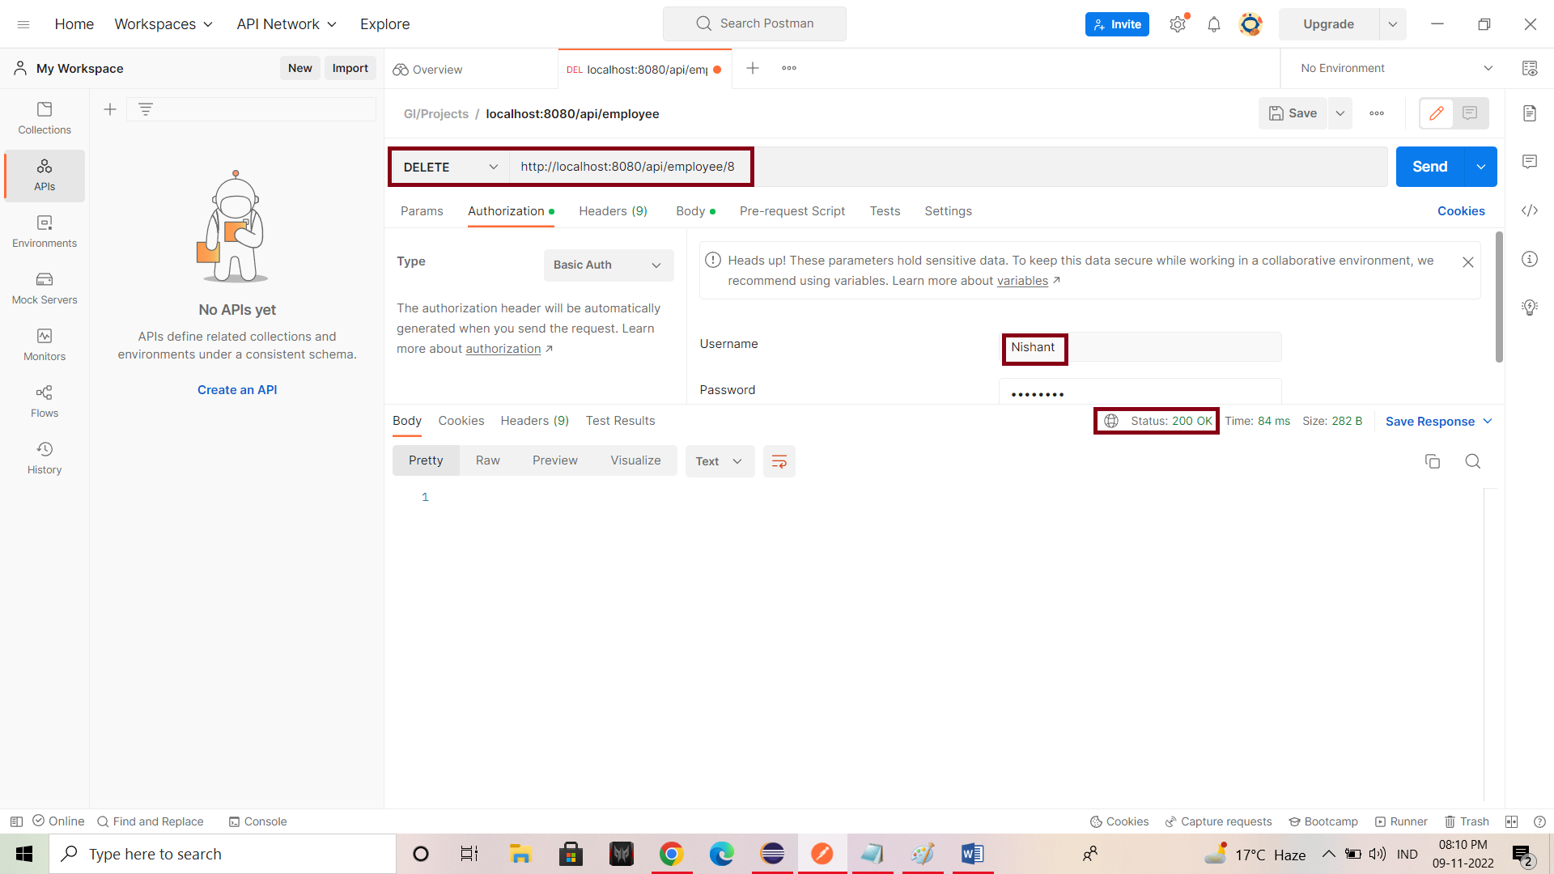

* **Screenshot showing DeleteById API for User Role.**

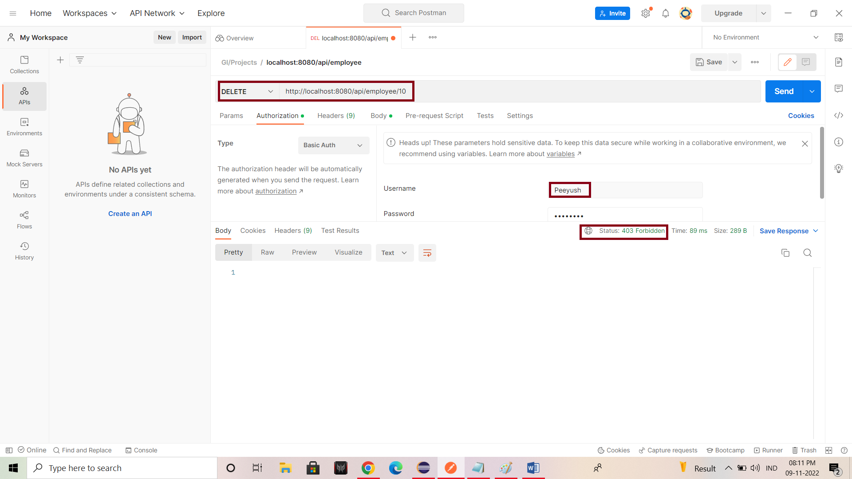

* **Screenshot showing Delete API for Admin Role.**

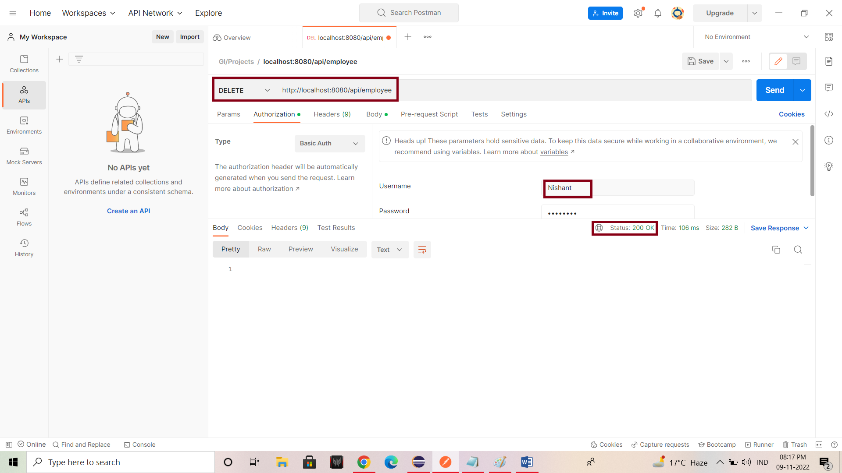

* **Screenshot showing Delete API for User Role.**

